Configuring application to receive the data from the cloud

|  |  |
| --- | --- |
| **Team ID** | **PNT2022TMID50805** |
| **Project Name** | **Hazardous Area Monitoring for Industrial Plant powered by IoT** |

Configuring cloudant data:

1.

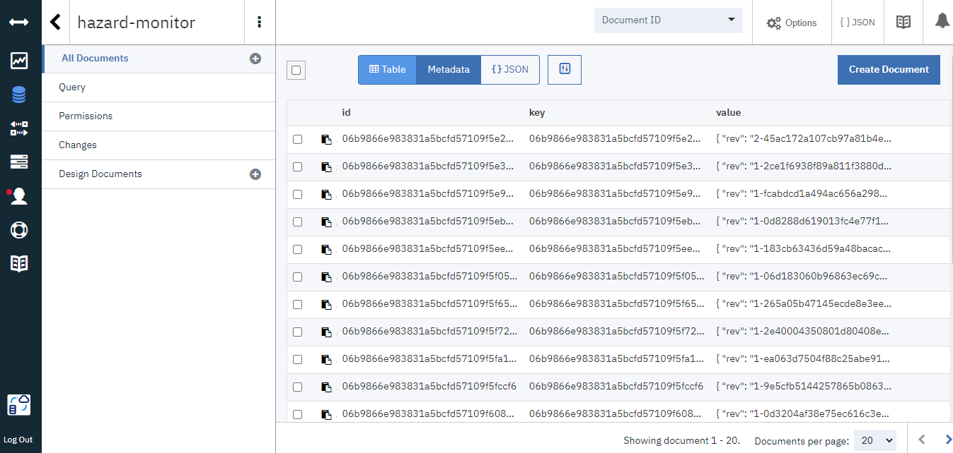

2.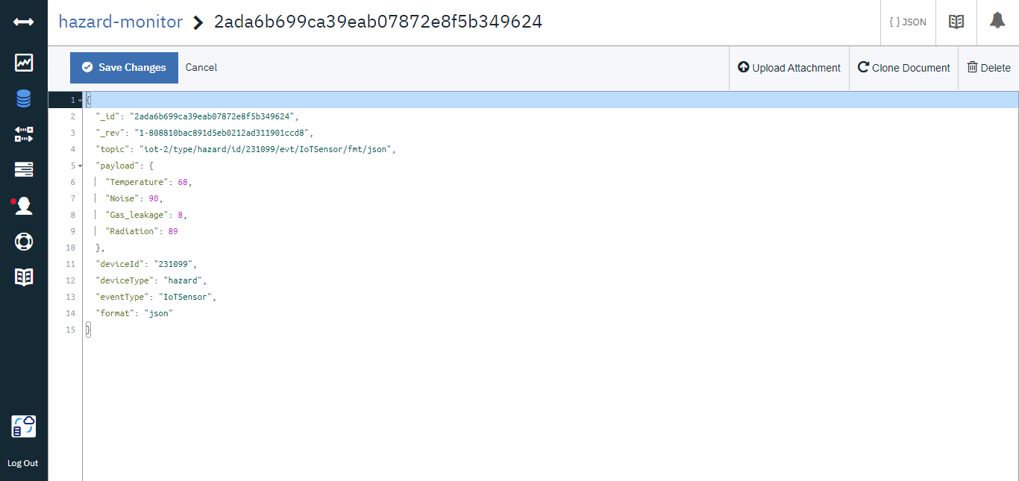

Received data from cloudant DB:

